Peacebuilding Games
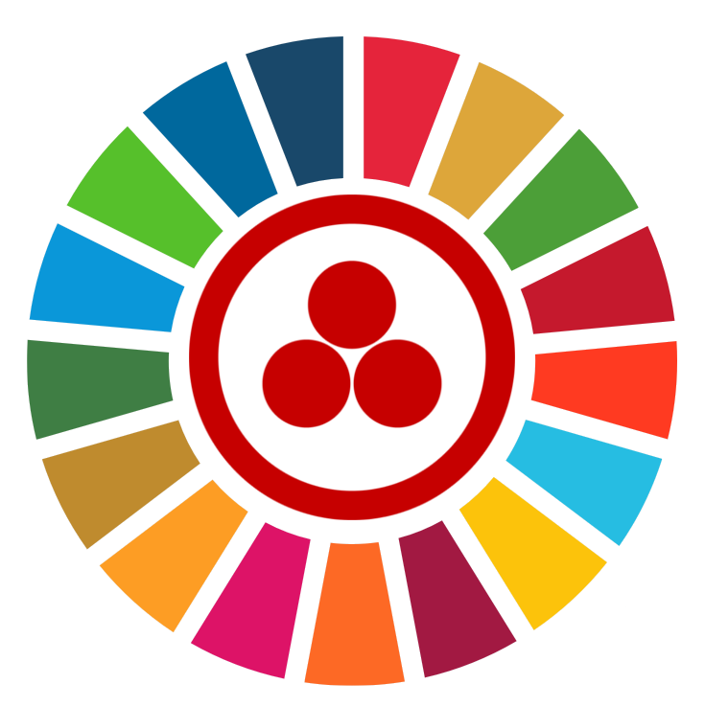
Summary
Inspired by Buckminster Fuller's World Peace Game (https://en.wikipedia.org/wiki/World_Game) along with the Model United Nations educational simulation (https://en.wikipedia.org/wiki/Model_United_Nations) we developed collaborative games rules to nourish mutualistic relationships, increasing in age and difficulty,
to be played under parental guidance [PG] with respectful language by two or more players simultaneously,
fostering friendly recreational pedagogic dialogue concearning individual and social glocal agency interlinks
understandment for the generation of United Nations Sustainable Development Goals advocates proficiency.

Proposer
Ecumenic Creative Operations
https://ecumenic.github.io
ecumenic@protonmail.com

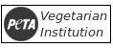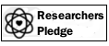

Schedule Synchronization
1. Decide one player to have the gamemaster role of organizing the schedule design and development.
2. Players decide a role playing scenario such as fantasy, cyberpunk, time-travel, terraforming, or else.
3. The gamemaster explains the needed schedule synchronizations according to the decided scenario.

Relational Recollection
1. Decide among players a relational scope such as family, teachers, jobs coleagues, or intimate partners.
2. Write down the best virtue that person has given you sharing a little story on how it was transmited.
3. Other players feedback each virtue with another virtue and comment it without knowing who it is.

Upcycling Tidying Cleaning
1. Decide among players a consensual place for the game to happen such as a household, institution, or else.
2. Prepare a scheduled plan to move every object out of their places and clean all objects and spaces.
3. According to site specificities decide also values for objects upcycling reuse and also for charity donations.

Peacekeeping Mission
1. Decide a real or fictional, humanitarian or ecologic, peacekeeping scenario with at least ten specificities.
2. Each player must write down five previous knowledges and four tools to solve the decided scenario.
3. Players must explain how they intended to solve the proposed problem with their knowledges and tools.

Sustainable Development
1. Decide among players a common issue to be solved in their current lives situations to be addressed.
2. Analyze each of the United Nations Sustainable Development Goals aims and proposed methodologies.
3. Use each of them to make a collective strategy for the decided issue using its language and techniques.

World Interfaith Peace
1. Decide one player to have the gamemaster role of scheduled organizationa nd judging the gameplay.
2. Decide among players a common issue to be solved in their current lives situations to be addressed.
3. Each player represents a specific laic or faith agency dialoguing to find practicala actions and solutions.

